Climate Change

Project Call

Full Proposal Packet

This packet contains detailed instructions outlining the requirements to information to successfully submit your full proposal. Please reach out to proposals@biomade.org with questions.

Submission Guidelines
- Submission Deadline: Wednesday, March 1, 2023 11:59 PST, no exceptions
- Materials must be submitted through the portal, linked here
- All information outlined below is required for the proposal to be considered, unless otherwise noted
- The project’s lead organization is responsible for submitting the full proposal materials on behalf of the team
- Please attach all documents in a zipped format to the submission form
- All project partners must be BioMADE members at the time of submission. Reach out to membership@biomade.org if you have questions.

Requirements Check List
☐ Cover Sheet
☐ Proposal Materials
☐ Technical Narrative (Maximum 13 pages)
☐ Statement of Work (SOW) Guidelines- Attachment 1
☐ Budget Template
- Pro Tip: Use the 2-year budget template that has been provided, ensuring you complete all tabs
☐ Quad Chart
☐ Block flow diagram of manufacturing processes
☐ Supporting Materials
☐ Proposal Cover Letter (provided by organization’s Authorized Official)
☐ Letters of Commitment (optional)
☐ Subrecipient Questionnaire Profile
- Pro Tip: This form is only required if the organization(s) have not submitted a completed profile in the past year, reach out to proposals@biomade.org to confirm status
☐ Current and Pending Support Form

Next Steps
Following the submission of the full proposal, BioMADE will complete an internal technical and administrative review of the documents provided. If more clarification is required, a BioMADE team member will reach out to the lead contact to request missing documents or additional information.

Cover Sheet

Project Information Summary

Project Title (max 80 characters): | Click to add Project Title
Abbreviated Working Title (max 35 characters): | Click to add Working Project Title
Project Lead: | Click to add organization name
Project Partners | Click to add organization(s) name
Total Project Cost: | $ Click to add dollar amount
Requested BioMADE Funds: | $ Click to add dollar amount
Contributed Cost Share: | $ Click to add dollar amount
Project Start Date: | Click to add date
Project Duration (months): | Click to add duration in months
Do any project partners intend to publish data or research derived from this project? (If yes, please see the SOW attachment for more details.) | Choose an item.

[Insert Working Project Title and Lead Organization Name]

Technical Narrative (maximum 13 pages)

Instructions:
Please complete this packet and submit to the portal, here, no later than Wednesday March 1, 2023 at 11:59 PT.

Please use this template to compose a clear, concise, and complete technical description of the planned project activities. The content submitted for this section should be for the complete project rather than each participating organization. There is a strict 13-page maximum for the proposal’s Technical Narrative (sections A-I). You are not required to use all 13 pages. The recommended page counts next to each section’s heading is a suggestion to assist in formulating a well-balanced proposal but are not mandatory. It is encouraged that you closely adhere to all formatting instructions and guidance as failure to comply may impact the proposal’s eligibility.

Please maintain the following formatting:

- Retain the bold subsection headings (sections A-I)
- Retain the general document formatting (one-inch margins, 11-12-point Arial font, single space)
- Retain the CONFIDENTIAL information security footer
- Delete all italicized text, including all instructions, section guidance text, and page count recommendations prior to submitting the full proposal
- The use of tables and figures to support your narrative is encouraged
- Citations are not included in the total page count
- Save this document using the following file name format:
- [Organization Name]_[PI’s last name]_CC_FullProposal_[yyyymmdd].
- If more than one proposal is submitted by the same PI, use [Organization]_[PI’s last name]_CC_FullProposal _[keywords]_[yyyymmdd], where the keywords are 1-3 words that adequately identifies the proposed work effort.
- Please attach all materials as a single zipped folder when submitting the full proposal

Executive Summary: [250 words max]
Summarize the proposed work including the technical objectives and how they are consistent with the project call technical priority areas, as well as the projected impact of the project. Please also describe how the outcome of the project will benefit the Department of Defense. The executive summary will not be considered confidential and will possibly be shared with leaders within the Department of Defense. Please to not include proprietary information in the executive summary.

- Background: [up to 1 page recommended]
Summarize the relevant technical background information needed to assess the proposal. The proposal reviewers will be experienced in general chemical engineering, biotechnology, and biomanufacturing processes.
- Relevance: [0.5 page recommended]
Describe the potential application or use-case within the Department of Defense that will be enabled by this innovation. The section will be evaluated by members of BioMADE’s Government Program Management Team to determine suitability of application.

D. Proposed Innovation: [Up to 1 page recommended]
Summarize the key innovation that will be developed and tested in this project. Describe the impact this innovation will have on the bioindustrial manufacturing ecosystem, including how the proposed work addresses the project call for innovations to mitigate the causes or consequences of global climate change.

E. Technical Approach and Justification: [3-5 pages recommended]
The major objective of the project proposal is to provide a clear description of the technical approach and anticipated outcomes. This section should provide insight into the technical foundation and justification for pursuing this project, including alignment to the BioMADE climate change priority areas. For projects developing a manufacturing process, a block-flow-diagram showing unit operations needed for scale-up production and downstream processing/product formulation should be included as a separate attachment that will not count towards the total page limit (details below). Please specify metrics by which the new technology can be characterized and assessed as well as the provisional standards and thresholds a successful product would meet. Definable metrics and corresponding measurement assays are required. Stretch goals are optional but encouraged.

F. Project Timeline: [1 page recommended]
Build an anticipated schedule of objectives, tasks, and milestones for the project. Use the template provided in Attachment 1 (SOW Guidelines) to create the project timeline. Number tasks, subtasks, and milestones according to objectives, and for projects with multiple partners, consolidate all tasks into a single timeline with consistent numerical identifiers. Project timelines should be embedded in the proposal document.

G. Products and Deliverables: [Up to 1-page recommended]
Describe the reports, publications, software, prototypes, Intellectual Property (IP), and other products that are expected to result from the project. Describe how these products will benefit the BioMADE community, for example through member-restricted access, data-sharing, etc., with specific consideration to how project partners, if any, may resolve differing data access and sharing parameters. Reminder: the milestones, deliverables, and timeline for the project should align to the unified SOW (see Supporting Materials for more information) provided by the team lead.

H. Ecosystem Benefit: [up to 0.5 pages recommended]
Succinctly describe how successful completion of your project will produce IP or knowledge that will benefit the broader biomanufacturing community. Projects funded within this mechanism will not be required to follow BioMADEs Intellectual Property Management Plan (IPMP), but project participants can still choose to make their funded results or IP available to the community. Projects that justify a community benefit will receive higher scores during proposal review.

I. Safe, Secure, Sustainable, and Socially Responsible (4S) Integration: [Up to 1 page recommended]
Please outline, in detail, how funded or cost-shared effort on this project will advance the 4S mission of BioMADE to engender a robust culture of responsible and safe conduct for the bioindustrial manufacturing ecosystem. Your proposal is expected to address integration of at least one component of 4S. Goals articulated in this section should be connected to the project schedule and milestones and to the budget/budget justification. Please consider the following when integrating 4S concepts into your proposal:
- For safety and/or security, for which some standards exist in professional norms and regulation, please identify ways in which your project will help improve compliance, safety, and security (e.g., by development of best practices or amendment of certain standards) or will advance these fields by identifying areas in need of additional or different guidance, particularly with respect to emerging areas of research and development.
- For sustainability, please describe how your project will meet or exceed emerging norms and standards for environmental protection, reduction of greenhouse gases or development of business models that are adapted to long-term economic accessibility and stability for a wide range of users.
- For social responsibility, please describe your plans for community engagement, whether as education or consultation; or for workforce development that addresses the need for greater diversity and inclusion; or for creative initiatives to bring appreciation of biotechnology science and economic possibilities to the general public.

Supporting Materials (not included in total page count)

Instructions:
Each organization participating in the project is responsible for submitting items A-D. The Principal Investigator from the lead institution is responsible for coordinating unified documents covering items E-K. It is suggested that item L be referred to by your organization’s Sponsored Projects Office or contracts team.

A. Proposal Cover Letter:
A Cover Letter signed by your organization’s Authorized Official within each project organization to legally bind that organization, including:
- Your organization’s full legal name
- Subaward type proposed (e.g., cost reimbursable)
- Submission date and a Proposal Validity Period of 90 days
- Each organization’s commitment to joining BioMADE and remaining a member in good standing during the duration of the proposed work

B. Letter(s) of Commitment
Please provide any Letters of Commitment relevant to the project, e.g., interested parties or project vendors.

C. BioMADE Subrecipient Questionnaire:
Provide a completed copy of the BioMADE Subrecipient Questionnaire for each member institution of the proposal team. This form is a yearly compliance requirement, therefore may not be needed if the organization has applied for BioMADE funding recently. Please reach out to proposals@biomade.org to confirm status.

Current and Pending Support
Please report all research projects or activities requiring a portion of time of the investigator/researcher and key personnel must be included. This includes projects with no salary support. Projects may be funded by Federal, state, local or foreign government agencies, public or private foundations, commercial organizations, etc. Do not include expired awards or rejected proposals.
Proposal List Order:
- The first entry should be the current proposal that is being submitted to BioMADE; this should be labeled as “Pending;”
- Next, list all pending proposals, including those anticipated to be submitted, in reverse chronological order (earliest anticipated award date first)
- Then list all active grants, with the most recently awarded first.

E. Budget and Budget Justification:
Provide a detailed budget for project costs for each team institution in the attached Microsoft Excel Budget Template. It is required that submitting teams use the provided template. Cost description MUST contain a detailed plan for providing cost-share at a 1:1 match of BioMADE funds. Cost share requirements are for the project as a whole and may be shared disproportionately across the team.
Please complete the Budget Justification and Monthly Spend Plan tabs of the file, ‘2Y BioMADE Project Budget Template.xls’. In the template, Budget Period 1 refers to year 1 and Budget Period 2 to year 2. Detailed explanations of your budget requests are required for justification, as is a considered Monthly Spend Plan. Additional documentation (quotes, etc) for large expenditures may be requested. Please provide if you have them to save time in processing your proposal. Budgets will not be approved, and proposals will not be considered complete, without completion of all sections of the Project Budget Template.

F. Facilities and Infrastructure Description:
Provide a description of the facilities and infrastructure, including critical equipment, that will be leveraged by each team member to complete the proposed work. Note where each piece of critical equipment is located (e.g., lead organization, partner organization, or vendor/service provider).

G. Key Personnel:
Identify the key technical personnel (Principal Investigator and key personnel within the partnering organizations) who will be involved. For each, briefly describe their roles and responsibilities on this project, and their relevant expertise. Please note that removal of critical personnel from a project during the project duration may prompt a contract review.

H. Statement of Work (SOW):
The lead member organization shall submit a unified SOW, collaborating with project partners to collate all required information. Each section must clearly identify each member organization’s responsibilities, as well as appropriately align to the individual partner’s budget and budget justification. Please see the SOW Guidelines (Attachment 1) for more details and examples.

I. Foreign Participation Plan:
Teams planning on incorporating foreign organizations or individuals as team members should contact BioMADE for pre-approval. Additional details will be provided based on the

J. Quad Chart:
Provide a completed copy of the attached Quad Chart Template that holistically describes the project. Please use Arial font style, no smaller than 10-point font
- Industry Need/Solution (2-4 sentences each) – Define the industry/defense need this project is addressing; provide a brief overview of how the project provides a solution
- Infographic – Provide a figure to highlight technical innovation of the project
- Plan (6-8 bullet points) – High-level strategy and steps to reaching project desired project outcome
- Updates – Leave blank, for internal BioMADE use

K. Block Flow Diagram
Provide a block flow diagram of the proposed technology as it is expected to exist in a commercial manufacturing facility. Use a separate shading or border to denote the specific area of the process / product upon which your proposal will focus. Where appropriate, provide additional description in the figure caption. a.) For biobased chemicals or materials, show key steps all the way from fermentation to final packaging. Ideally, each block should correspond to a single unit operation. If you do not know the name or type of unit operation appropriate for a step, simply give a short statement of the intended operation, e.g., remove protein, strip product molecule from solvent, dry powder, recycle solvent, or reduce particle size to < 100 um. Draw and label all inlet and outlet streams from a given unit operation, including feedstocks, products, wastes, as well as major utility requirements, e.g., cooling water, compressed air, electric, or steam. Identify any unit operation that may be highly intensive in terms of temperature, pressure, energy consumption, water use, waste generation, or presents a significant safety hazard. Identify key process consumables, e.g., media components, chromatography resins, acids / bases, and DSP solvents. A formal mass & energy balance is not required. b.) For a product that requires physical / mechanical processing steps, e.g., metal casting, forming, machining, welding, cutting or assembly; polymer melting, blowing, extrusion, spinning, weaving, or lamination, please include each unit manufacturing step in an individual box. c.) For other types of proposals, such as information networks, databases, data analysis and AI projects, strategic networks/partnerships, modeling software, or fundamental research proposals, construct your diagram as appropriate with defined flows of materials, input information, output information, logic constructs, and other abstract unit operations, e.g., similar to a flow-chart.
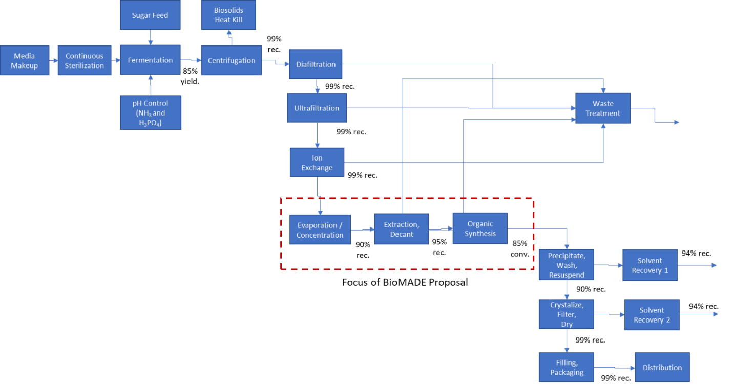

L. Subaward Agreement Template:
If your organization would like to review the subaward template, please reach out to proposals@biomade.org for more details. We encourage early review to expedite the subaward negotiations process if the project advances to provisional funding.

